AI Assisted Coding
Assginment-3.1
Name : M.Anirudh kumar
Batch No : 46
HT No : 2303A53033
Question 1: Zero-Shot Prompting (Palindrome Number Program) Write a zero-shot prompt (without providing any examples) to generate a Python function that checks whether a given number is a palindrome.
Task:
- Record the AI-generated code.
- Test the code with multiple inputs.
- Identify any logical errors or missing edge-case handling.
Prompt : #“Write a Python program that takes a number as user input and checks whether it is a palindrome number.” Code:
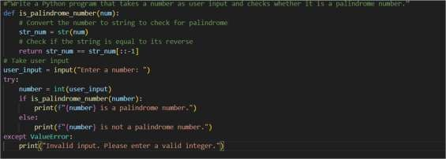
Output:
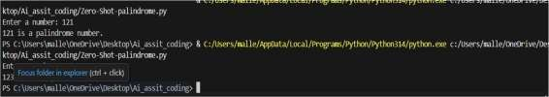
Analysis:
  - The zero-shot prompt generated correct basic logic for palindrome checking.
  - The initial solution lacked proper handling for negative and invalid inputs.
  - Additional validation was required to make the program more reliable.

Question 2: One-Shot Prompting (Factorial Calculation) Write a oneshot prompt by providing one input-output example and ask the AI to generate a Python function to compute the factorial of a given number.
Example:
Input: 5 → Output: 120
Task:
- Compare the generated code with a zero-shot solution.
- Examine improvements in clarity and correctness.
Prompt :
#“Write a Python program to compute the factorial of a number taken as user input.
Code :
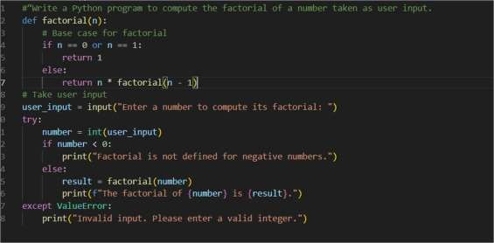
OUPUT :
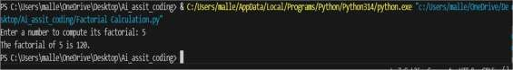
Analysis :
- Providing one example improved the clarity of the generated code.
- The program correctly handled negative numbers compared to zero-shot prompting.
- The logic was more structured and easier to understand.

Question 3: Few-Shot Prompting (Armstrong Number Check) Write a few-shot prompt by providing multiple input-output examples to guide the AI in generating a Python function to check whether a given number is an Armstrong number.
Examples:
- Input: 153 → Output: Armstrong Number
- Input: 370 → Output: Armstrong Number • Input: 123 → Output: Not an Armstrong
Number Task:
- Analyze how multiple examples influence code structure and accuracy.
- Test the function with boundary values and invalid inputs.
Prompt :
#“Write a Python program to check whether a number is an Armstrong number using user input.
Code :
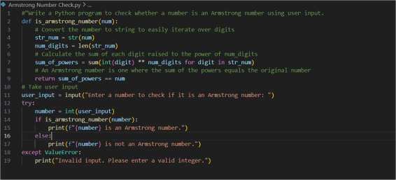
OUTPUT :
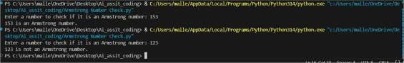
Analysis :
  - Multiple examples helped the AI identify the Armstrong number pattern accurately.
  - The generated code was well-structured and produced correct results.
  - Few-shot prompting reduced ambiguity compared to zero-shot prompting.

Question 4: Context-Managed Prompting (Optimized Number
Classification)
Design a context-managed prompt with clear instructions and constraints to generate an optimized Python program that classifies a number as prime, composite, or neither.
Task:
- Ensure proper input validation.
- Optimize the logic for e iciency.
- Compare the output with earlier prompting strategies.
Prompt :
#“Write an optimized Python program that takes a number as user input and classifies it as Prime, Composite, or Neither.
Code :
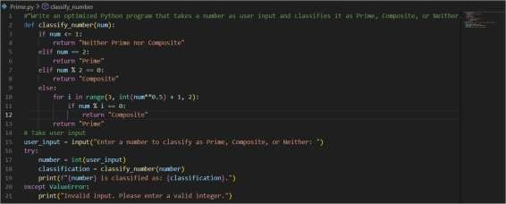
OUTPUT :
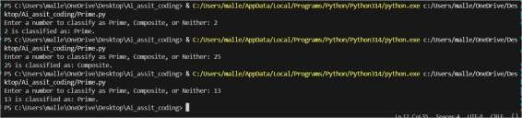
Analysis :
  - Clear instructions and constraints resulted in an optimized solution.
  - The program e iciently classified numbers using minimal iterations.
  - Proper input validation improved program reliability.

Question 5: Zero-Shot Prompting (Perfect Number Check) Write a zero-shot prompt (without providing any examples) to generate a Python function that checks whether a given number is a perfect number.
Task:
- Record the AI-generated code.
- Test the program with multiple inputs.
- Identify any missing conditions or ine iciencies in the logic.
Prompt :
#“Write a Python program that takes a number as user input and checks whether it is a
perfect number.” Code :
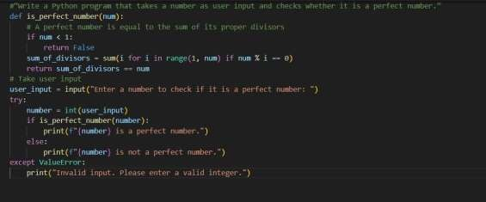
OUTPUT :
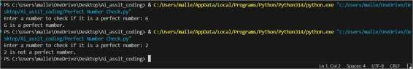
Analysis :
- The generated code correctly identified perfect numbers.
- The solution was ine icient for large inputs due to unnecessary iterations.
- Edge-case handling and optimization were missing initially.

Question 6: Few-Shot Prompting (Even or Odd Classification with
Validation)
Write a few-shot prompt by providing multiple input-output examples to guide the AI in generating a Python program that determines whether a given number is even or odd, including proper input validation.
Examples:
- Input: 8 → Output: Even
- Input: 15 → Output: Odd
- Input: 0 → Output: Even Task:
- Analyze how examples improve input handling and output clarity.
- Test the program with negative numbers and non-integer inputs.
Prompt :
#“Write a Python program that determines whether a number is even or odd using user input with proper validation.
Code :
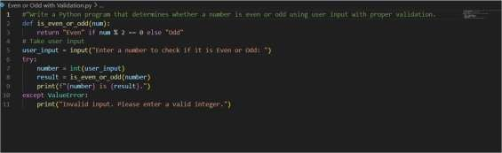
OUTPUT :
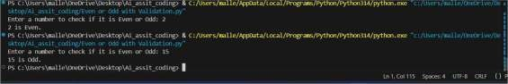
Analysis :
- Examples improved input handling and output clarity.
- The program correctly handled negative numbers and zero.
- Input validation prevented errors for non-integer values.

